Consolidation of the Pima Villages: 1690-1848
Pima-Maricopa Irrigation Project Education Initiative
2003-2004

Restoring water to ensure the
continuity of the Akimel O’otham
and Pee Posh tradition of agriculture

Re

The cultural makeup of the Pimas—their large, successful irrigated agricultural fields, their friendly and hospitable spirit and a natural enmity with the Apaches (who were at war with everyone, including the Spanish)—made them of great geopolitical importance to Spain. The Pimas owned a very strategic geographical location along the river and had shown a willingness to befriend the Spanish. Spain was well aware that if it wished to maintain its California settlements, those settlements had to be connected to the Spanish towns in Sonora and New Mexico.
Part 44

The most desired land route to California went right through the Pima villages. It was here that water and supplies for the journey could be purchased and friendship found. This put the villages squarely in the middle of Spain’s objective of establishing and maintaining a road to the west. Spain was aware that Russian (from Alaska southward), English (from the east) or French (from the northeast) influences could lead to ultimate control of the area by any of those colonial nations. To prevent their expansion into the fertile interior west, the Gila River had to be under the control of Spain. This could only be accomplished through Pima fidelity or faithfulness to the Spanish Crown.
In trying to extend and protect its northern frontier, Spain encouraged the Pimas to consolidate their villages along the middle Gila River. At the time of Kino’s first visit to the Pimas, in 1694, Pima rancherias, or scattered clusters of settlements, were spread out all along the river. A wet 17th century had encouraged Pima farmers to increase their agricultural production of corn, beans, squash and cotton. In so doing, they expanded their villages along the Gila River and its tributaries. By the beginning of the 18th century, Pima villages alone were spread along the river for more than 100 miles, extending from the Casa Grande ruins to the great bend in the Gila River. Other Pima-Sobaipuris villages were spread along the San Pedro River. Many of these isolated villages were prone to enemy raid and war parties.
While their agricultural lands were mostly along the river and near their villages, the Pimas also farmed some of the lowlands of the Gila, Salt and Santa Cruz Rivers. West of Picacho Peak, Pima villages along the Santa Cruz River engaged in ak chin, or dry farming. The Pima-Sobaipuris in the San Pedro Valley were already trading their corn for “hatchets, cloth, sackcloth, blankets, chomite, knives, etc.,” from Spanish colonists in New Mexico.
In the 18th century there were a number of environmental changes in the Gila watershed. Less rain fell, meaning the land was more arid than before. As the Pima grew more wheat—and stored it for long periods—they became prone to more enemy raids, mostly from the Apaches. As these raids increased in frequency, the people began to move their villages closer to each other, in effect contracting their villages to better protect themselves from raids. Despite contraction—and perhaps a result of it—the Pima’s grew more crops than ever before.
When Kino first visited the Pimas he did not specifically mention any village other than noting he held a mass at Casa Grande ruins. Nonetheless, he visited some of the villages along the river, finding the people blessed with a fertile and luxuriant land for growing food and fiber crops. When he returned to the Gila River in November of 1697 to determine the friendly disposition of the Pimas, Kino passed through eleven Sobaipuris villages along the San Pedro River where Chief Coro “splendidly” welcomed him. A year later, Kino was welcomed by “more than one thousand souls, men and women,” at Sutaquison and another “three hundred men who represent three hundred families and more than one thousand persons” in the village of Santa Catarina del Cuytoabagum (or Aquituni), northwest of Picacho Peak along the Santa Cruz River.
While the Pima population slowly increased over the latter decades of the 18th century, much of it resulted from the depopulation of other Piman tribes to the south and east. Thirty years after Kino’s last visit to the Gila, the German Jesuit priest Ignacio Xavier Keller led a delegation to the Sobaipuris, discovering their villages had “broken up” due to Apache raids. By 1760, when Jesuit missions in Arizona were facing a crisis of survival due to Indian depredations, the Catholic Church sought to strengthen its missions in the Santa Cruz Valley by consolidating the Sobaipuris villages with those of the San Xavier Papago and other Pima villages on the Santa Cruz River near Tucson. Within two years, the San Pedro Valley was abandoned, with the Sobaipuris having moved west to the Santa Cruz, north to the Pima villages or having been exterminated by the Apaches. The Sobaipuris villages along the Santa Cruz River north of Tucson eventually faced a similar fate, adding to the Pima population.
When Jacobo Sedelmayr visited the Pima villages in the 1740s, he found the people engaged in intensive agriculture on both sides of the Gila River. Such farming enabled the people to provide handsomely for themselves. But it also resulted in an increased frequency of Apache raids, leading to the concentration of most Pima villages in the area of Sutaquison (modern area of Sweetwater). Here a fertile floodplain four miles wide and continually restored by the flooding of the Gila River enabled the people to farm the floodplains. While centered in Sutaquison, the villages were concentrated in three large rancherias on “a pleasant fertile country” some thirty miles in length.
By the middle of the 1700s, Father Ignacio Pfefferkorn wrote the Indians of Sonora had lost over half of their population because of disease, specifically noting the “unconverted Indians” along the Gila and Colorado Rivers were also declining in population. Nonetheless, the Pimas continued to increase in population due to a dependable food supply (which supported a greater population) and consolidation of other Piman villages. While Father Garces traveled from San Xavier to the Gila to baptize Pimas suffering from outbreaks of measles, in 1770, the villages continued to increase in population. When Juan Bautista de Anza passed through Pima country, in 1774, he found the villages consolidated along the Gila River between Casa Grande ruins and the Sierra Estrella Mountains, with the central area of settlement much more restricted. Notwithstanding earlier accounts, Anza estimated the Pima population at more than 5,000. Juan Diaz, traveling with Anza, observed six villages in close proximity to each other, “because thus united they are better able to withstand the continuous assaults of the Apache.”
Apache raids were not only increasing in frequency but they also were becoming more deadly. In April of 1780, the Apaches dealt the Pimas one of their most disastrous assaults. Disguised as Spanish soldiers, the Apaches descended on a party of Pimas, killing or capturing 120. Six years earlier, they struck Sutaquison, killing 60 Pimas. To better protect themselves, the Pimas began posting sentries (or guards) on hills near the villages to warn the people of enemy raids and moved their villages to open country away from the river. When Pedro Font asked why they had done so, the Pimas told him the village site near the river with its thick trees and brush caused them to fare poorly against the Apaches. Moving away from the river—onto open ground—they were better able to defend themselves. As raids intensified, other villages withdrew to the south bank of the Gila River to higher and more strategic locations. Smaller villages and rancherias pulled closer to each other to create a “metropolis form of settlement.” Villages were now fenced and surrounded by irrigation canals and agricultural fields to better protect the people against enemy raids.
By the early 19th century, Pima villages had withdrawn and consolidated from more than 100 miles in length to fewer than 25. So consolidated were the villages that a California-bound 49’er described the whole distance for 18 miles along the river as an “Indian city.” Individual homes were “1 to 2 miles from the river” and “thickly settled” with the space in between “a series of the finest fields I ever saw.” The easternmost Pima village was now located some 15 miles west of Casa Grande ruin.
While Apache raids encouraged consolidation, ecologic and economic adaptations to wheat and increased trade served as the basis of it. As Pima agriculture intensified, production increased. Increased production resulted in enlarged trade networks and modified settlement patterns. By the beginning of the 1800s the river was used by the Pima to sustain a thriving agriculture-intensive economy. With village consolidation on the south bank, the river was also used to protect the people from enemy attacks.
Consolidation of the Pima Villages

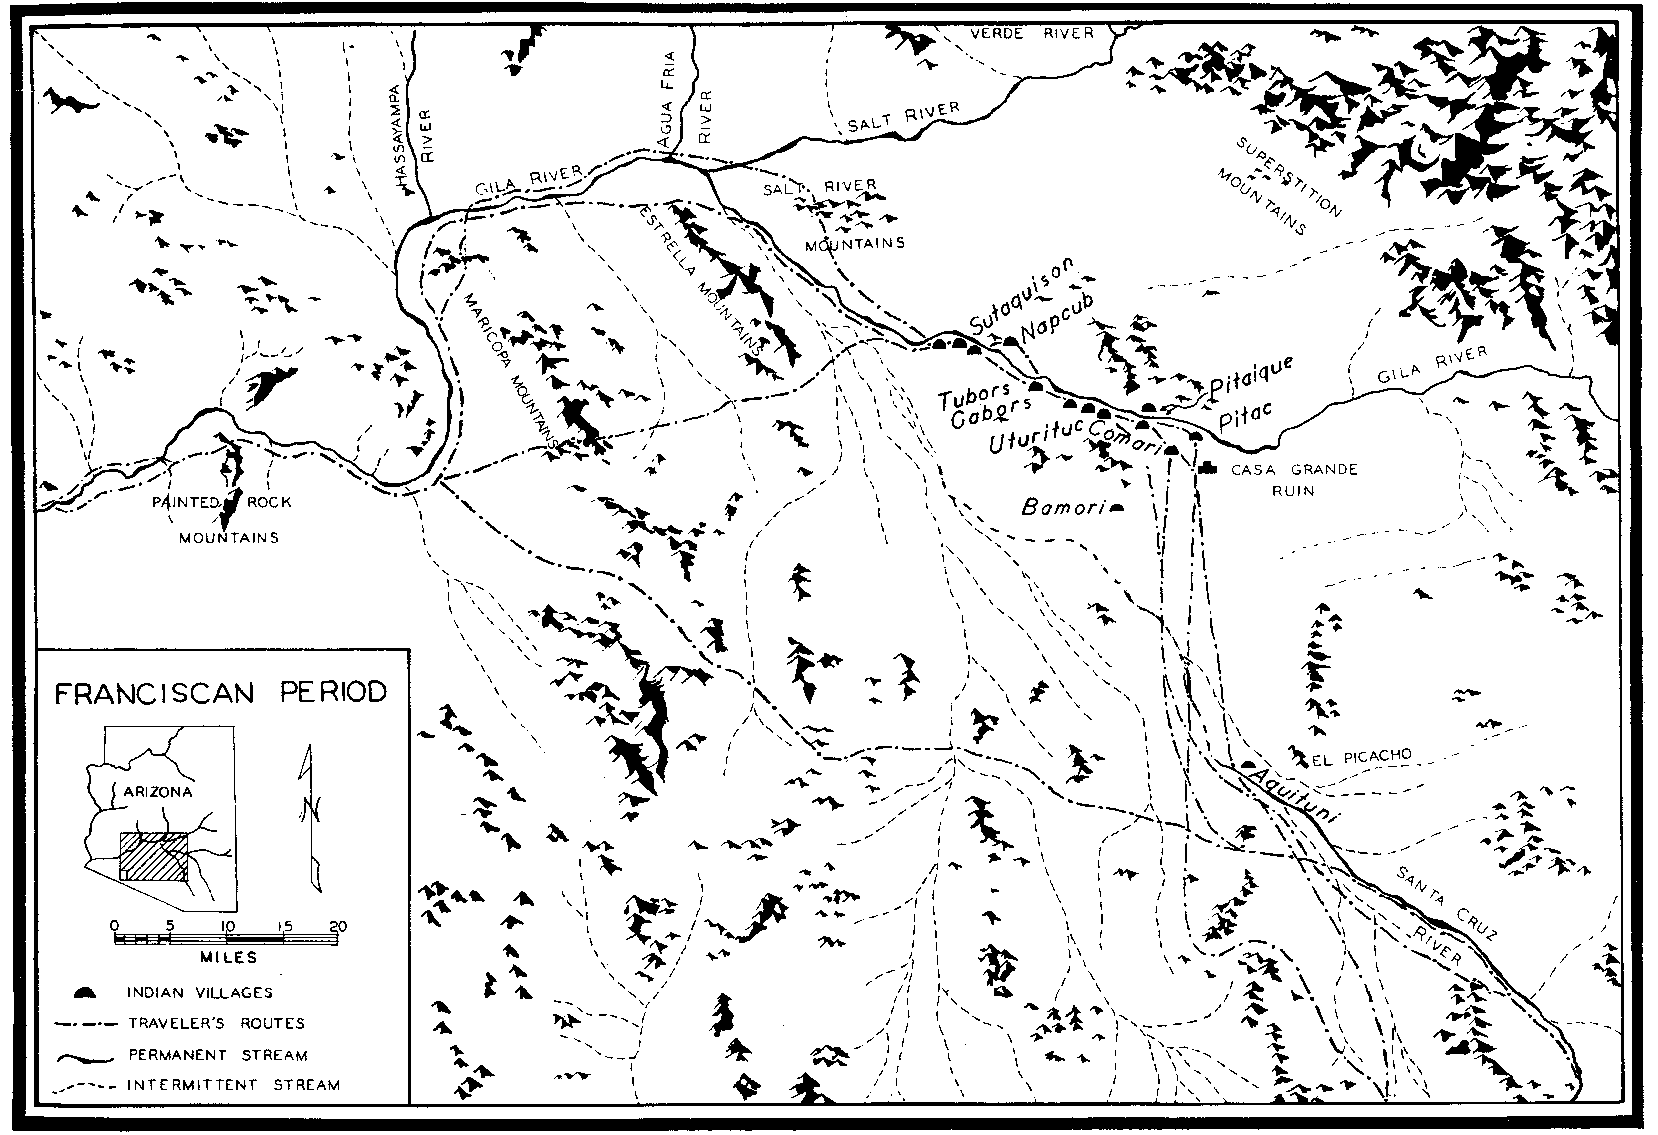
(Source: Paul H. Ezell, The Hispanic Acculturation of the Gila River Pimas, 1961)
Teacher Plan for “Consolidation of the Pima Villages, 1690-1800”
Objectives

Students will be able to:

- Explain reasons for consolidation of the Pima villages in the 17th and 18th centuries and how water influenced those decisions.

- Analyze worldwide water availability and discuss ways they can manage and protect water for future generations.
Terms to know and understand

- Enmity
- Geopolitical
- Fidelity
- Arid
Critical Thinking:

- What is the difference between a natural loss
of water and a politically induced loss of water?
Spain did not note or record any evidence of a drought or famine in Pima country between 1690 and 1850. Yet, within thirty years of the American era drought and famine were widespread among the Pimas. What differences existed between the Spanish settlements and the American settlements that might account for this? Was it all related to environmental changes? Would these changes have occurred even if Spain had continued to occupy Southern Arizona? What factors do we know of today that can induce drought or famine conditions? How can we prevent these conditions?
Activities:

- Students may know that the earth is covered with water. What they may not recognize is that only a very tiny fraction of all water is available for human use. Illustrate this for students. You will need a 1000 ml beaker, a 100ml graduated cylinder, a 10 ml cylinder and an eyedropper. Start with the 1000 ml beaker filled with 970 ml of water. This represents all the available water in the world. Ask students where most of this water is located. They should tell you in the oceans. Next pour 24 ml of water into the 100 ml graduated cylinder. This represents all the fresh water available. Put salt in the remaining 946 ml of water in the beaker to represent salty water unsuitable for human consumption. Since nearly 80% of all fresh water is locked up in polar caps, pour 6 ml of water into the small cylinder to represent the available fresh water. Of this, just 1.5 ml is surface water (the rest is groundwater). Now take the eyedropper and remove a single drop of water (.003 ml). Release it into a metal cup so students can hear it. This represents the estimated clean, fresh water that is available for human consumption and represents roughly 7,000,000 ml of water per capita (based on 6 billion people). `Discuss with students why it is important to manage and protect the Gila River Indian Community’s water resources.
About P-MIP

The Pima-Maricopa Irrigation Project is authorized by the Gila River Indian Community to construct all irrigation systems for the Community. When fully completed, P-MIP will provide irrigation for up to 146,330 acres of farmland. P-MIP is dedicated to three long-range goals:
- Restoring water to the Akimel O’otham and Pee Posh.
- Putting Akimel O’otham and Pee Posh rights to the use of water to beneficial use.
- Demonstrating and exercising sound management to ensure continuity of the Community’s traditional economy of agriculture.

